Setup and Preparation

Servicing a SuperDARN Transceiver  
Step 1

Content

1. Introduction 2

2. Equipment Setup 2

3. Transceiver Preparation 2

4. Conclusion 4

# Introduction

Before servicing a transceiver box, the servicing equipment needs to be set up correctly and the transceiver box itself needs to be prepared.

# Equipment Setup

You will require the following equipment for setting up and testing the transceiver boxes:

* 4-Channel Tektronix Scope (TDS 3054C)
* Tektronix current sensor module and current probe (TCPA300 & TCP312)
* Agilent 4-Channel Scope (MSO6104A) (1-1MΩ, 2-50Ω, 3-50Ω, 5-1MΩ)
* Radar Lab 2.0
* AWG (33250A)
* High Voltage Probe
* DMM
* 50 Ohm Dummy Load
* Bench Power Supply (60V, 10A)
* SMA 50 Ohm Terminator

# Transceiver Preparation

The transceiver box should be laid out and wired according to diagram in *Figure 1*. Inspect the box and make sure that each PCB is in the correct position and that all wires are in place.

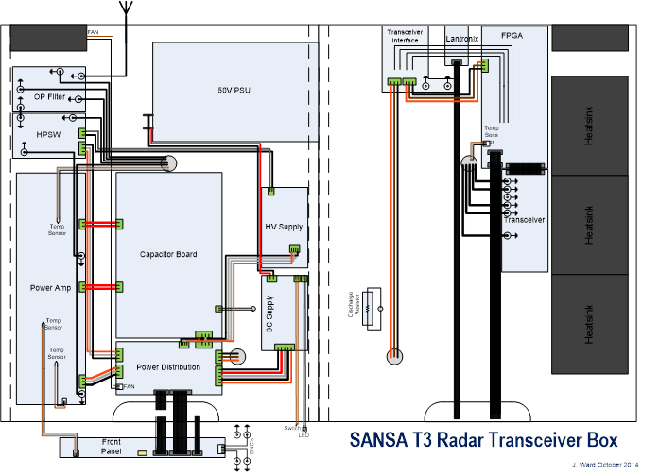

Figure 1. Transceiver box layout diagram.

Wiring of all boxes follows the same colour code, as presented in *Table 1*.

Table 1. Wiring colour codes.

|  |  |
| --- | --- |
| Black | Ground |
| Orange | 15 V |
| Red | 50 V |
| Grey | 850 V |
| White | Signal |

Upon completion of the preliminary inspection, follow the steps below to complete the preparation of the transceiver box:

1. Check the green Phoenix connectors for any loose wires and tighten the screws if necessary.
2. Check that the boards are mounted properly to the aluminium plate, especially the power amplifier, and tighten the screws if necessary.
3. Check that there are no loose debris inside the box, like small pieces of solder wire, which can cause a short.
4. Starting on the bottom side of the box remove all the green Phoenix connectors from their headers.
5. Remove the chassis fan connector (P7) from the Power Distribution Board.
6. Remove the ribbon cables (P2, P3 and P5) from the Front Panel Board.

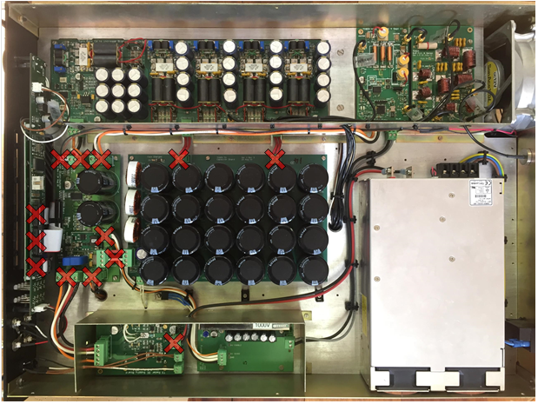

Figure 2. Transceiver box connections after preparation.

**NOTE**:  
Older power distribution boards have a difference: There is a 15V cable (orange) running on the connector between the Power Distribution board and the Power supply board to the high voltage supply board. This is because the high voltage supply board now runs off 15V instead of 50V.

# Procedure

Once the environment is properly set up and the transceiver is prepared for the servicing, follow each of the following work instructions in order:

1. Work Instruction – SuperDARN – Servicing a 50 V Supply Board
2. Work Instruction – SuperDARN – Servicing a DC Supply Board
3. Work Instruction – SuperDARN – Servicing a Power Distribution Board
4. Work Instruction – SuperDARN – Servicing a Front Panel Board
5. Work Instruction – SuperDARN – Servicing a Capacitor Board
6. Work Instruction – SuperDARN – Servicing a High-Power Switch Board
7. Work Instruction – SuperDARN – Servicing a Power Amplification Board
8. Work Instruction – SuperDARN – Servicing a FPGA Board
9. Work Instruction – SuperDARN – Servicing a RF Transceiver Board
10. Work Instruction – SuperDARN – Calibrating a Transceiver

# Conclusion

This concludes the setup and preparation work instructions for the SuperDARN Transceiver Box Servicing procedure. The next step in the procedure is to test the 50 V power supply.